BOOK WORLD PRAGUE 2017

ORDER OF STAND CONSTRUCTION

11 – 14 May 2017, Palace of Industry, Prague Exhibition Grounds (Holešovice)

Application Deadline: February 24, 2017

Orders are accepted by Svět knihy, s.r.o.

Consultations for individual requirements (and/or module alternations) provided by
Svět knihy, s.r.o. , Fügnerovo nám. 1808/3, 120 00 Prague 2, Czech Republic
Contact: Michaela Mecerová, Tel.: +420 602 339 071, Fax: +420 224 498 754, E-Mail: info@svetknihy.cz

EXHIBITOR (Address for invoicing)

Company Name
Street |  | P. O. Box
City |  | Postal Code
Country |  | VAT Number

Contact Person
Telephone |  | Mobile
E-Mail |  | Fax

ORDER OF STAND CONSTRUCTION
Module: ……
Ordered Exhibition Space: .............. m² Dimensions (l x d): ..............m x ..............m

PRICE LIST
Module A: 690 CZK / m²
Module B: 880 CZK / m²
Module C: 950 CZK / m²
Module D: 5,500 CZK / 4 m²
Prices of all modules (except module D) do not include electrical connection and necessary electrorevision.
Stands may be customized according to individual requirements.

 Electricity - up to 2,2 kW: 4,035 CZK
 Electricity - up to 4,4 kW: 6,022 CZK
 Electricity - up to 6,6 kW: 8,151 CZK
 Electricity - up to 10,5 kW: 10,997 CZK

Necessary electrorevision of the exposition
1 - 14 m² 550 CZK
15 - 30 m² 950 CZK
31 m² and more 1,500 - 2,500 CZK

A triple socket and electrical installation included in the price.
A list of electric appliances and their capacities can be found in the Exhibitor’s Manual that will be sent to you.

 We order 24-hours electrical supply for 500 CZK / 4 days (for refrigerator).

STAND PRINTING
In the space provided below, please write exactly what is to be printed on the overhang of your stand.
Up to 25 letters are included in stand price (Helvetica font unless otherwise indicated).

FURNITURE AND EQUIPMENT
Item | Size | CZK / Piece | Pieces
OCTANORM WHITE
counter | 50 x 100 | 330
counter with a shelf | 50 x 100 | 390
counter | 100 x 100 | 330
counter with a shelf | 100 x 100 | 390
counter | 50 x 50 | 250
glass counter (upper part) | 50 x 100 | 650
glass counter (upper part) | 100 x 100 | 830
glass case | 50 x 100 | 900
glass case | 100 x 100 | 1,250
glass case | 50 x 50 | 750
lockable staff area | 100 x 100 (walls + folding door) | 600
lockable staff area | each add. 1m² | 200
lockable folding door |  | 420
AL grid panel (ceiling) | 100 x 100 | 120
AL grid panel (ceiling) | 100 x 50 | 80
book shelf | 1m | 80
wall shelf (width 30 cm) | 1m | 80
shelf rack - 3 shelves | 50 x 100 | 350
shelf rack - 4 shelves | 50 x 100 | 390
wall - glass | 1m | 450
FURNITURE
square table | 80 x 80 | 190
round table | diameter 60-70 | 190
chair - upholstered |  | 120
chair - leather, chromium |  | 160
bar stool |  | 180
locker |  | 480
ELECTRO
refrigerator | 100 l | 1,000
electric cooker with a kettle |  | 160
coffee machine |  | 160
triple socket - extra |  | 70
extension cord |  | 70
spot light - extra |  | 140
OTHER EQUIPMENT
dish set - small |  | 260
dish set - large |  | 600
prospectus holder (“A” shape) |  | 390
coat hooks |  | 80
trash basket |  | 20
carpet, grey | 1m² | 110
GRAPHIC
company logo - symbol |  | 1,000 – 1,500
colour sheetings | 1m² | 330

STAND MODULES (Octanorm - white)

Should you desire for your stand equipment or arrangement different from that offered in our modules, please specify your conception in the area below:



We offer the corner stands for the same price too!

MODULE A
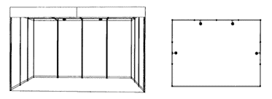

Includes: peripheral walls, front overhang, company name, stand number, lighting (1 spot light for each 3 m²), trash basket, open ceiling grid 1 x 1 m.
Not includes: electrical connection and necessary electrorevision.

MODULE B
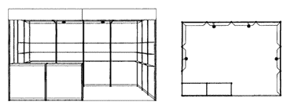

Includes: peripheral walls, front overhang, company name, stand number, lighting (1 spot light for each 3 m²), carpet, 3 shelves for each peripheral wall (excluding walls with sales counter), sales counter (100 x 50 x 100 cm) with a shelf, trash basket, open ceiling grid 1 x 1 m.
Not includes: electrical connection and necessary electrorevision.

MODULE C

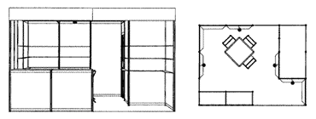

Includes: peripheral walls, front overhang, company name, stand number, lighting (1 spot light for each 3 m²), carpet, 3 shelves for each peripheral wall (excluding lockable staff area and walls with sales counter), sales counter (100 x 50 x 100 cm) with a shelf, trash basket, 1 table (square or round), 3 chairs (upholstered or folding), coat hooks or coat stand, lockable staff area - available only for stands of 12 m² and more, size of lockable staff area according to stand size, open ceiling grid 1 x 1 m.
Not includes: electrical connection and necessary electrorevision.

MODULE D (4 m²)

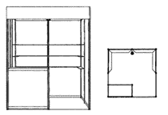

Includes: peripheral walls, front overhang, company name, stand number, 2 spot lights, carpet, sales counter (100 x 50 x 100 cm) with a shelf, 12 book shelves, trash basket, open ceiling grid 1 x 1m.

BOOKSHELF NORMAL SHELF
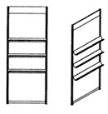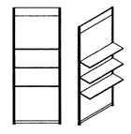

Note: Stand bookshelves may be substituted for normal shelves. If so desired, please inform us.

Invoice for services connected with stand construction will be provided by Svět knihy, s.r.o.
VAT at the statutory level is not included.
When ordering stand construction services from Svět knihy, s.r.o., this form is an integral part of the Book World Prague Registration.

Mailing Date:

Exhibitor’s Stamp & Signature:

